Roots to grow, wings to fly.











# •



•







Roots to grow, wings to fly.



➢

➢



➢

➢

➢

➢







# •

•



Roots to grow, wings to fly.









# •

•







The Sendco is Caroline Jobling and can be contacted at Headteacher@dove.staffs.sch.uk



•

•

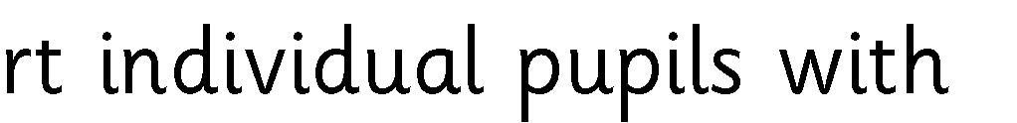

•



•



•



•



Roots to grow, wings to fly.

# •



•



•



•

•



•





•

•





• 

• 

•



•



•



Roots to grow, wings to fly.



# •

• 



•



•



• 



• 

• 

• 

•



Roots to grow, wings to fly.

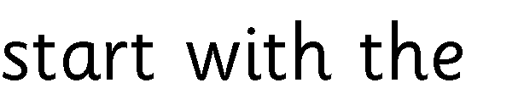





# •

• 



• 

•

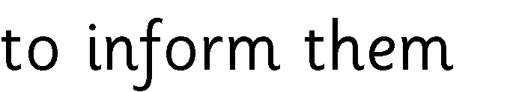

•

•

Roots to grow, wings to fly.



# •

• 



• 

• 

• 

•



•









Roots to grow, wings to fly.

•



•

•

•

•

# •

•

•



•

•



•

•

•

•

•

Roots to grow, wings to fly.







# •

• 



•



Roots to grow, wings to fly.

# •











•

•



•

Roots to grow, wings to fly.

# •



•



•





•

•

•

•

•



Roots to grow, wings to fly.







# •

•



•



•



•

•







|  |  |  |
| --- | --- | --- |
|  |  |  |
|  |  |  |
|  |  |  |
|  |  |  |
|  |  |  |

Roots to grow, wings to fly.













Roots to grow, wings to fly.





# •



•



•

 •

