




Roots to grow, wings to fly.








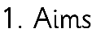
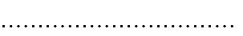


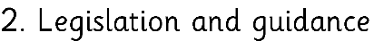

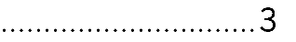


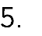




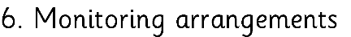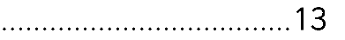





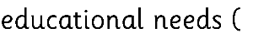

•

•


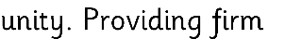

Roots to grow, wings to fly.


➢







➢
➢
➢
➢
➢






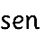
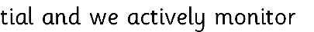




•

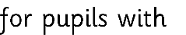
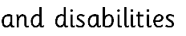

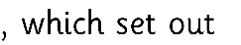



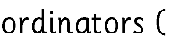


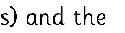

•

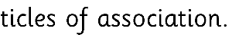



Roots to grow, wings to fly.




•

•







The Sendco is Caroline Jobling and can be contacted at Headteacher@dove.staffs.sch.uk


•

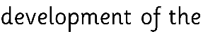






•

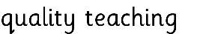
•


•
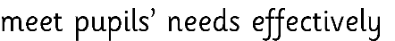
•



•

Roots to grow, wings to fly.

•




•



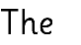


•

•

•


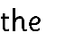

•




•



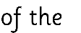

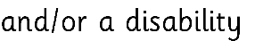
•



•
•
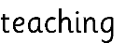
•



•



•

Roots to grow, wings to fly.






•

•

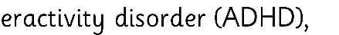
•


•

•





•
•
•

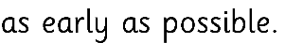
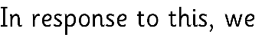

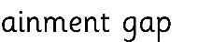
•

Roots to grow, wings to fly.


•

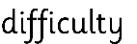
•
•

•








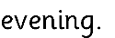

•
•

Roots to grow, wings to fly.








•
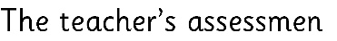

•
•
•
•
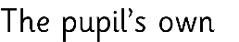
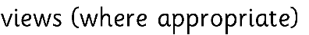
•
•








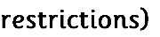


Roots to grow, wings to fly.



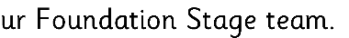
•

•

•
•
•

•
•
•






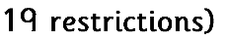


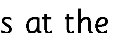
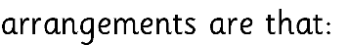
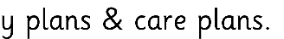

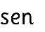

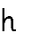

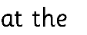


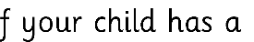


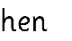
•

•
•

•
•

•
•

Roots to grow, wings to fly.
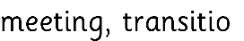




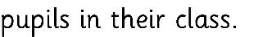
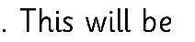







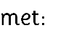

•

•

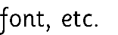
•

Roots to grow, wings to fly.

•


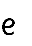


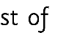
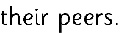

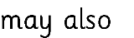


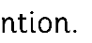









•


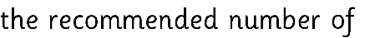
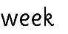
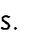
•

•

Roots to grow, wings to fly.




•


•
•






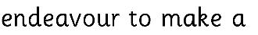
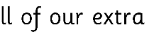
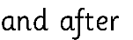

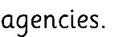
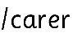
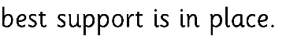





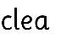


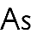
•
•
•
•

•


Roots to grow, wings to fly.

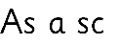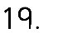


•

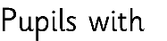

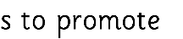
•


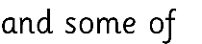

•

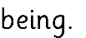

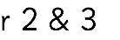
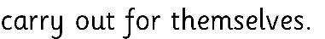
•

•

•

 |  | 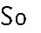
 |  | 
 | 
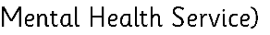 | 
 | 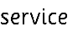

Roots to grow, wings to fly.


















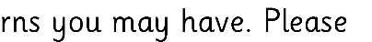


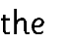

Roots to grow, wings to fly.




•

•

•
•




